**Lesson 10 Demo 1**

**Kubernetes Installation and Cluster Setup**



Steps to be followed:

1. Installing Kubernetes
2. Setting up a Kubernetes cluster

**Step 1: Installing Kubernetes**

1. To download and add the key to allow kubernetes installation, execute the commands mentioned below:

***sudo su***

***curl -s*** [***https://packages.cloud.google.com/apt/doc/apt-key.gpg***](https://packages.cloud.google.com/apt/doc/apt-key.gpg) ***| apt-key add -***

***sudo echo deb http://apt.kubernetes.io/ kubernetes-xenial main > /etc/apt/sources.list.d/kubernetes.list***



1. Update the apt-get package by executing the command mentioned below:

***sudo apt-get update***

1. Install the kubernetes and the tools required to manage it. Run the command mentioned below in the terminal:

***sudo apt install*** [***docker.io***](http://docker.io/) ***kubectl=1.20.5-00 kubeadm=1.20.5-00 kubelet=1.20.5-00***

**Step 2: Setting up a Kubernetes cluster**

1. Update the apt-get package by executing the command mentioned below:

***sudo apt-get update***

1. To initialize the cluster run the following command on the master node

***sudo kubeadm init***

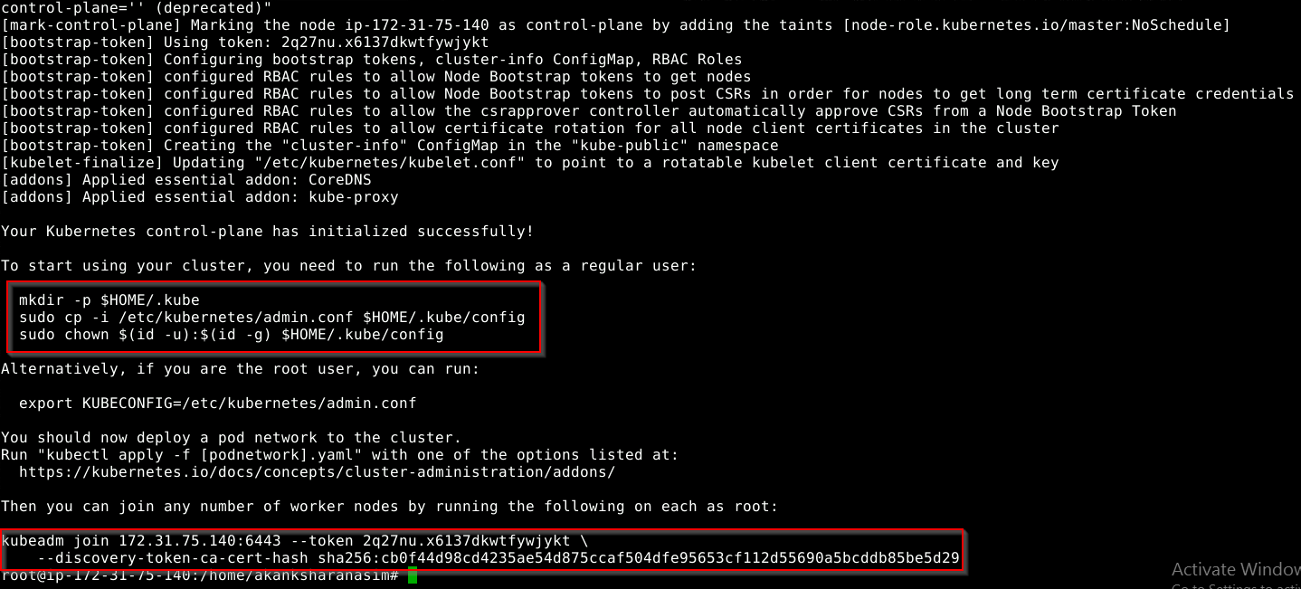

1. To start using your cluster, you need to run the following on master node:

***mkdir -p $HOME/.kube***

***sudo cp -i /etc/kubernetes/admin.conf $HOME/.kube/config***

***sudo chown $(id -u):$(id -g) $HOME/.kube/config***

1. You should see a single master node deployed on running the command:

***sudo kubectl get nodes***

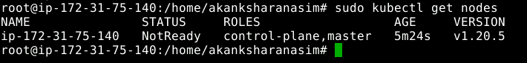

1. Copy the ***kubeadm join command*** that you can see on the screen of your master node

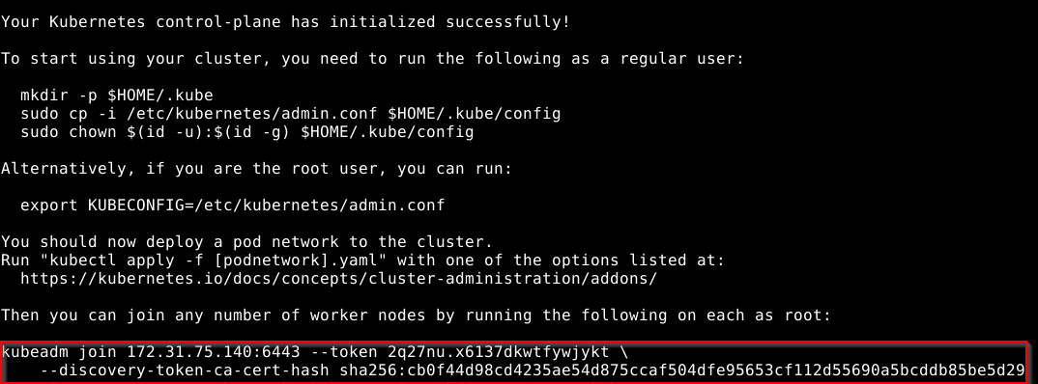

1. Run the copied *kubeadm join* command as a root user on the worker node. You can use the terminal only lab as a worker node. Make sure you have Kubernetes installed on the worker node and then run the below command.

***kubeadm join 172.31.64.38:6443 --token 425qb8.51rbrxc5h862g202 \***

***--discovery-token-ca-cert-hash sha256:a502867d97b05820f186e3ee748afddd9142aae4104aee804d30662148138bae***



1. On the master node, run the following command to install the weavenet plugin in order to create a network:

***kubectl apply -f "https://cloud.weave.works/k8s/net?k8s-version=$(kubectl version | base64 |tr -d '\n')"***

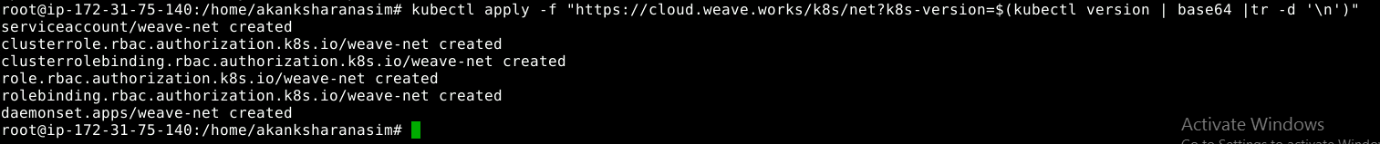

1. List all the nodes again to check the statusof nodes using the command:

***kubectl get nodes***

